

A Project Report On

AUTOMATION TESTING ON demotour WEBSITE

By

**Rohini Anil Raut**

Batch: ECA (2020-5334)

Course: School of Coding-Certified Software Test Engineer

Under the Guidance of,

Priyanka Desale

(Technical Trainer)

**EduBridge**

**INTRODUCTION**

This Project aims to do overall testing like functional testing, GUI testing on

website to check quality of application. It helps to improve quality of website and saves time for manually doing this testing. In this project our main focus is to check functionalities available on website. Also, it includes title check and all links count with their working status.

**SOFTWARE REQUIREMENTS**

* Operating System: Windows 10
* Browser: Latest version of Chrome
* IDE: Eclipse IDE
* Automation Tool: Selenium WebDriver
* Front-end: Java

TC01- Launch the browser and open Demo Tour Website.

System.*setProperty*("webdriver.chrome.driver", "C:\\Users\\user\\Desktop\\Selenium jar//chromedriver.exe");

WebDriver w1=**new** ChromeDriver();

w1.get("http://demo.guru99.com/test/newtours/index.php");

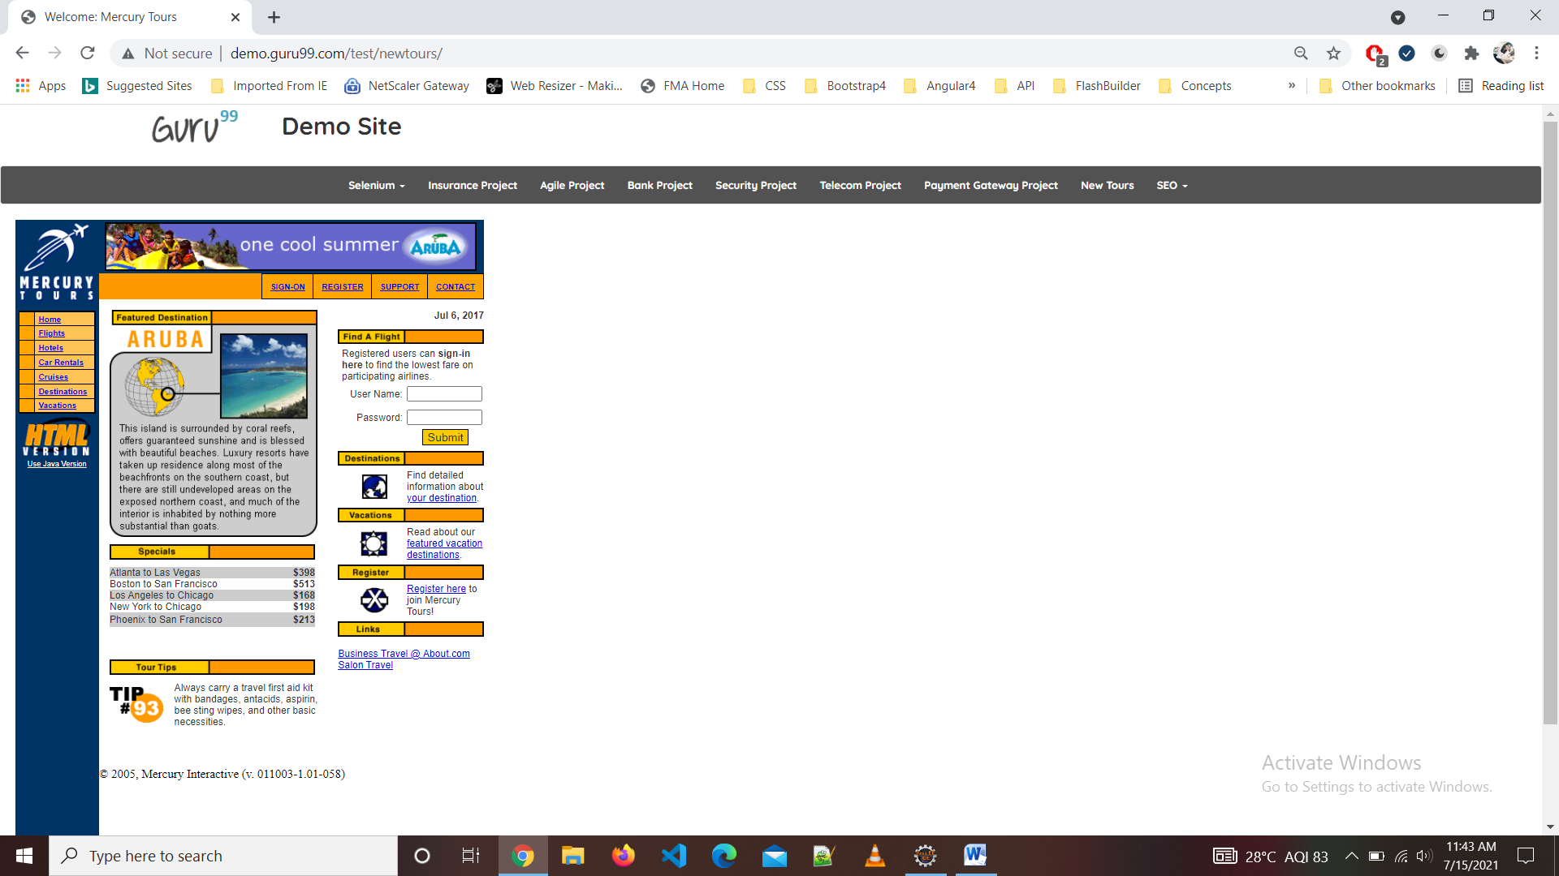

TC02-To check the functionality of SIGN-ON Button

w1.findElement(By.*linkText*("SIGN-ON")).click();

w1.navigate().back();

Thread.*sleep*(2000);

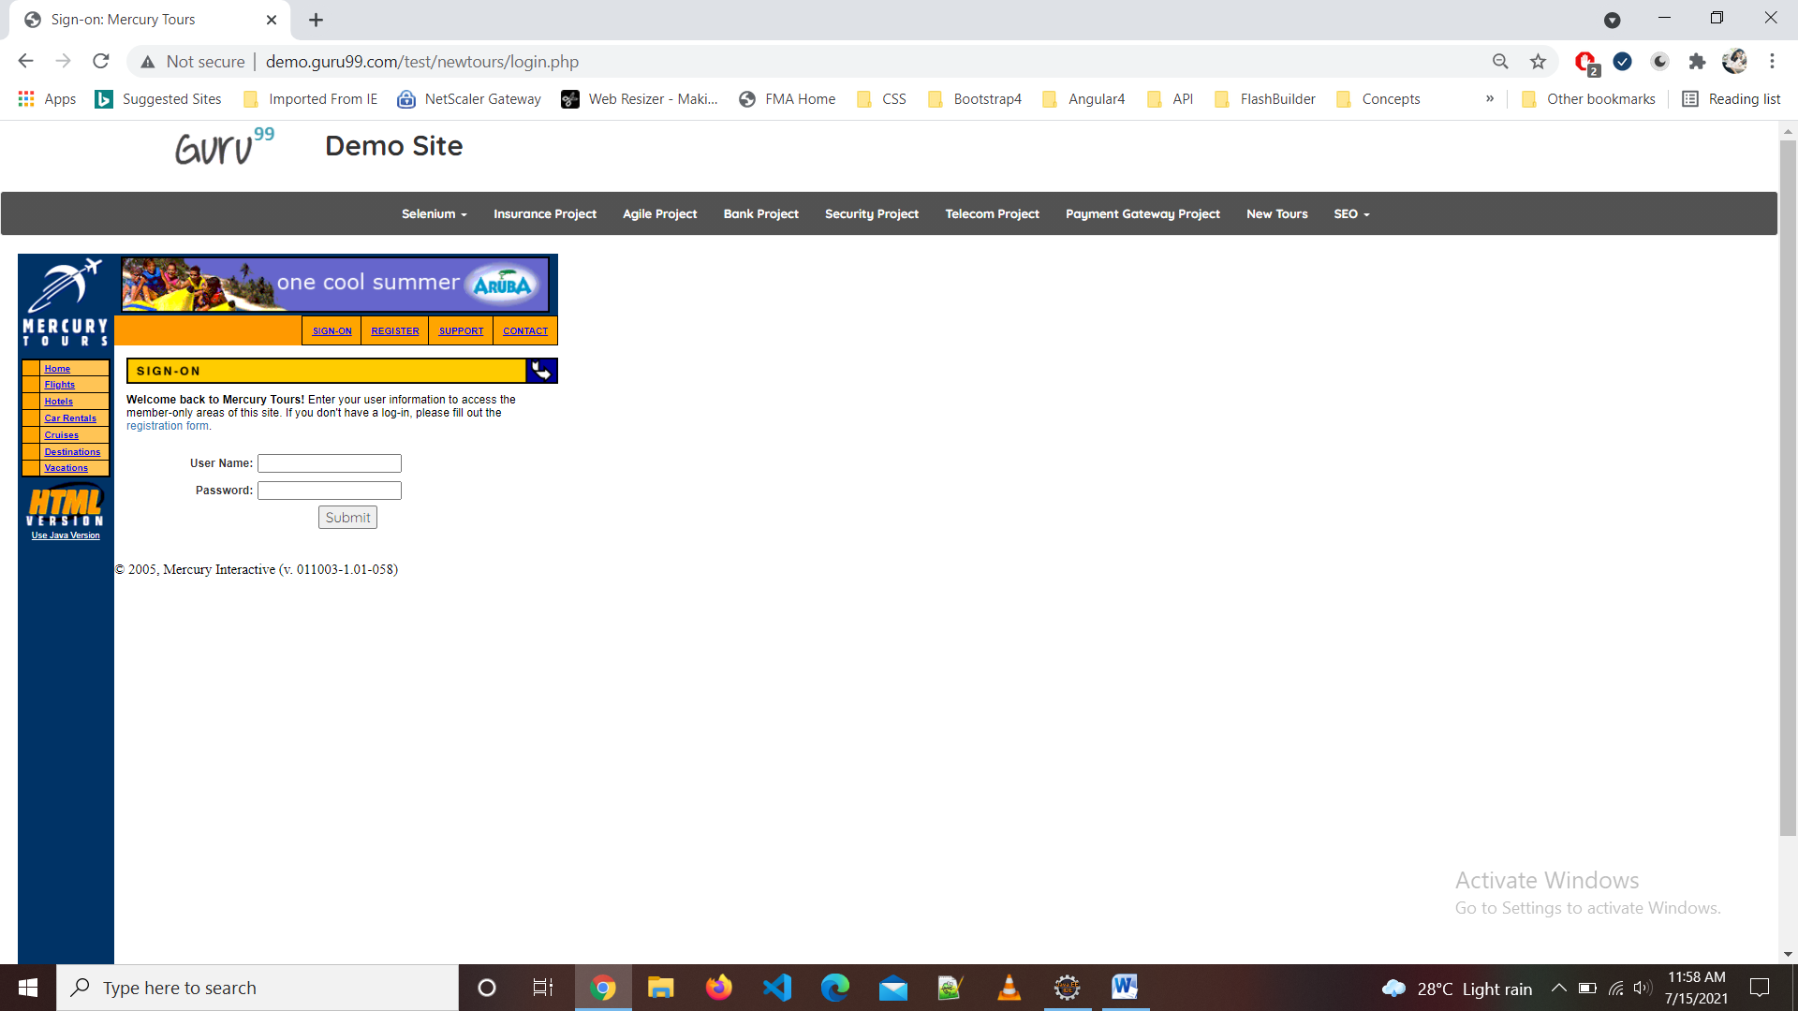

TC03-To check the functionality of REGISTER Button

w1.findElement(By.*linkText*("REGISTER")).click();

w1.navigate().back();

Thread.sleep(2000);

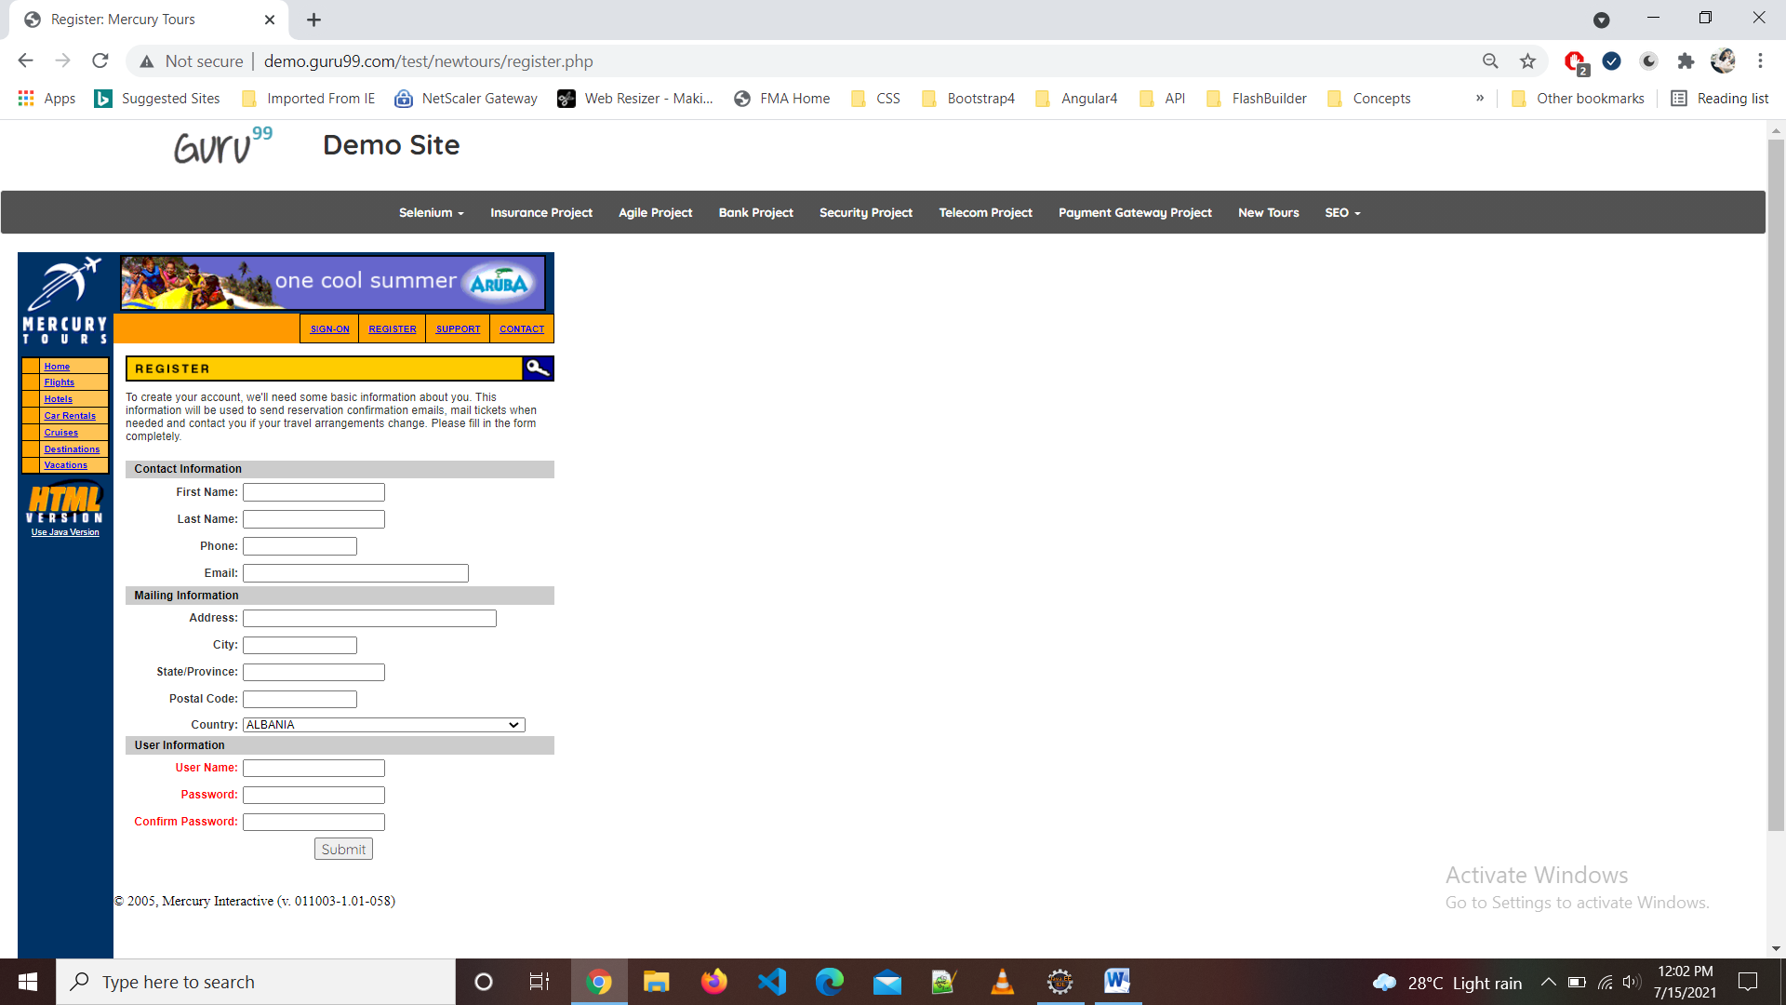

TC04-To check the functionality of SUPPORT Button

w1.findElement(By.*linkText*("SUPPORT")).click();

w1.navigate().back();

Thread.sleep(2000);

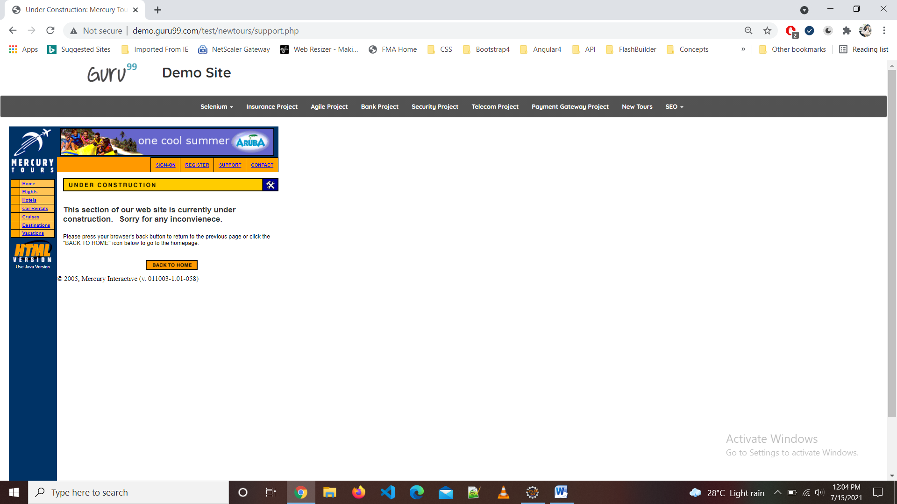

TC05-To check the functionality of CONTACT Button

w1.findElement(By.*linkText*("CONTACT")).click();

w1.navigate().back();

Thread.sleep(2000);

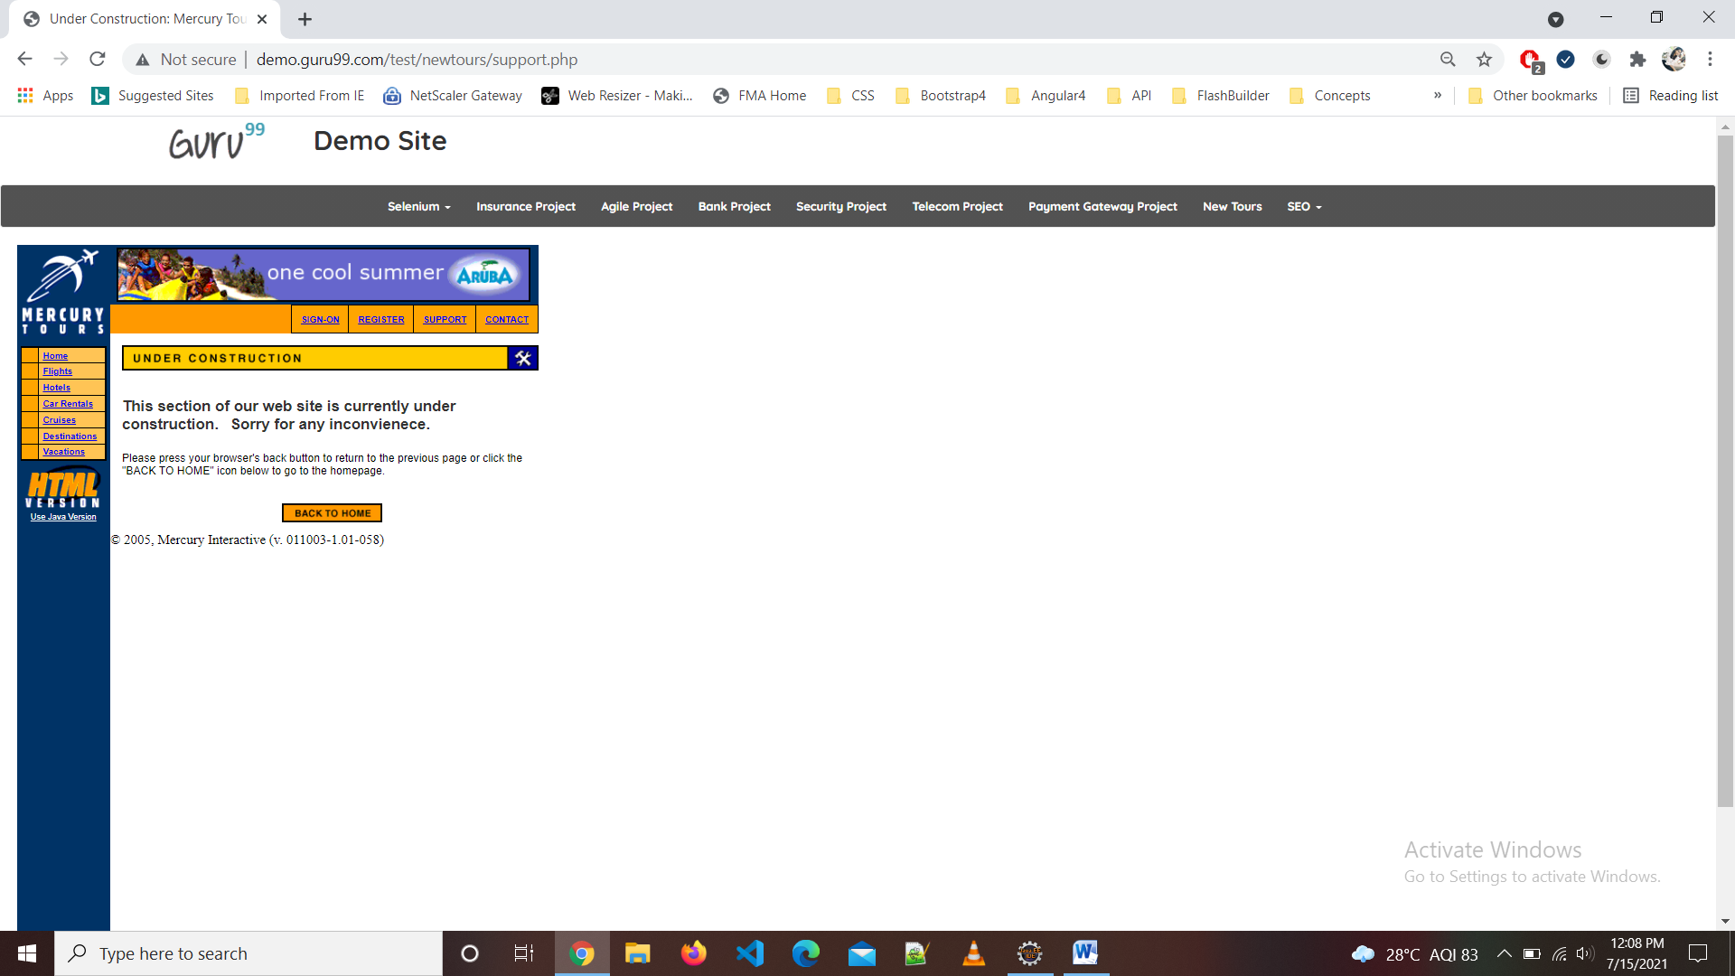

TC06-To check the functionality of HOME Button

w1.findElement(By.*linkText*("Home")).click();

w1.navigate().back();

Thread.sleep(2000);

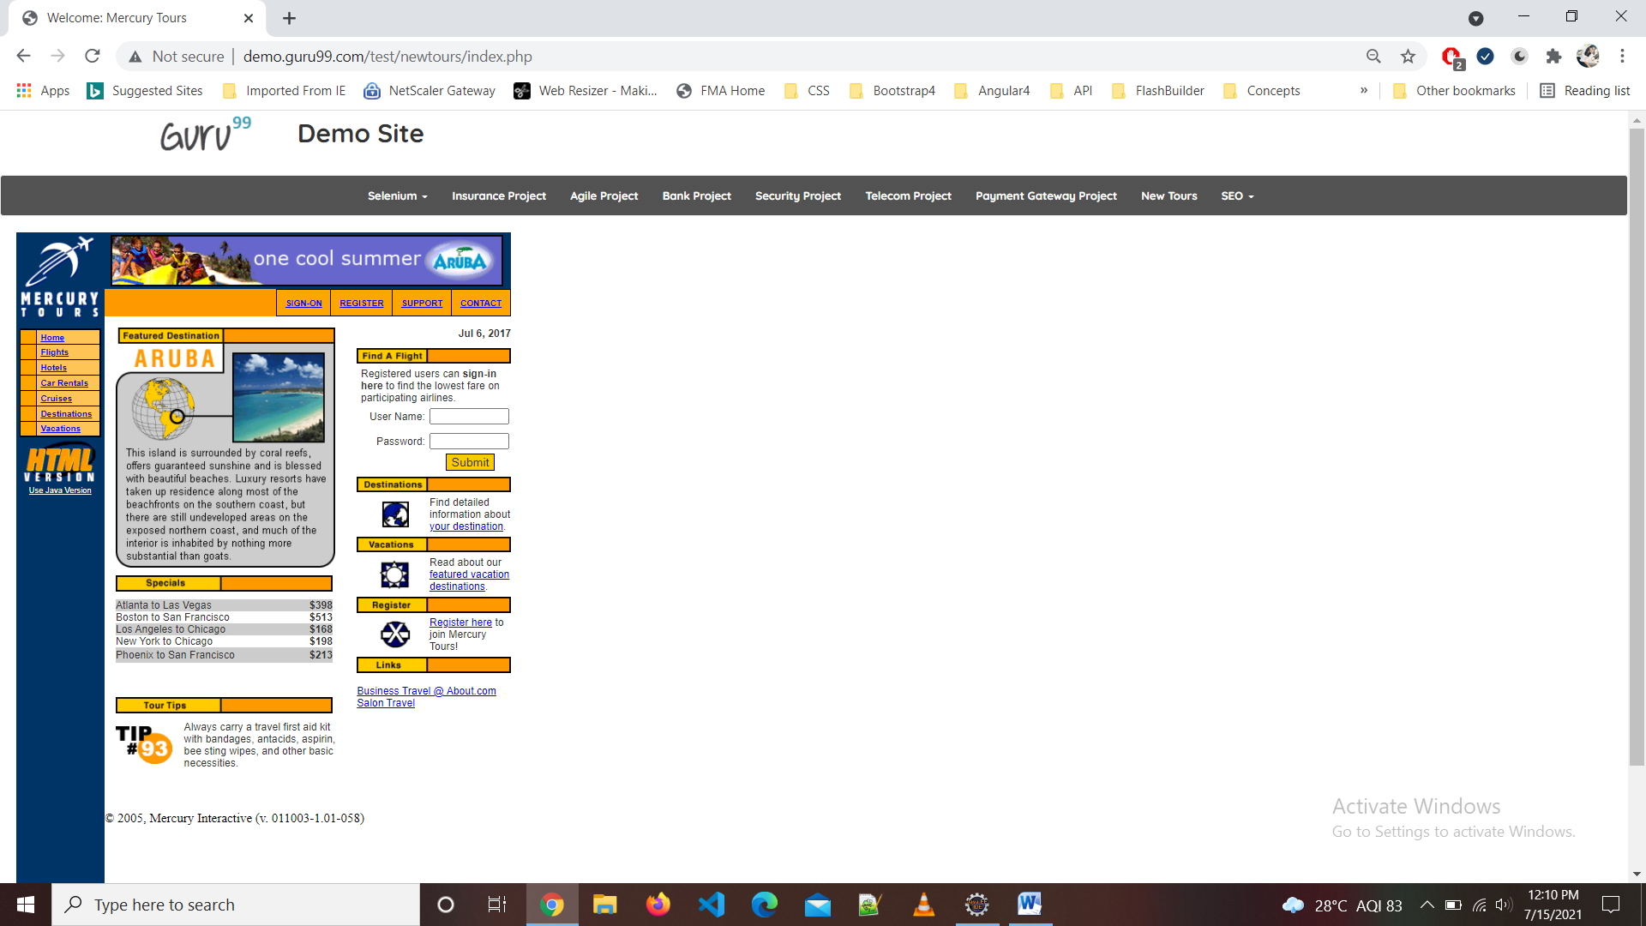

TC07-To check the functionality of FLIGHT Button

w1.findElement(By.*linkText*("Flights")).click();

w1.navigate().back();

Thread.sleep(2000);

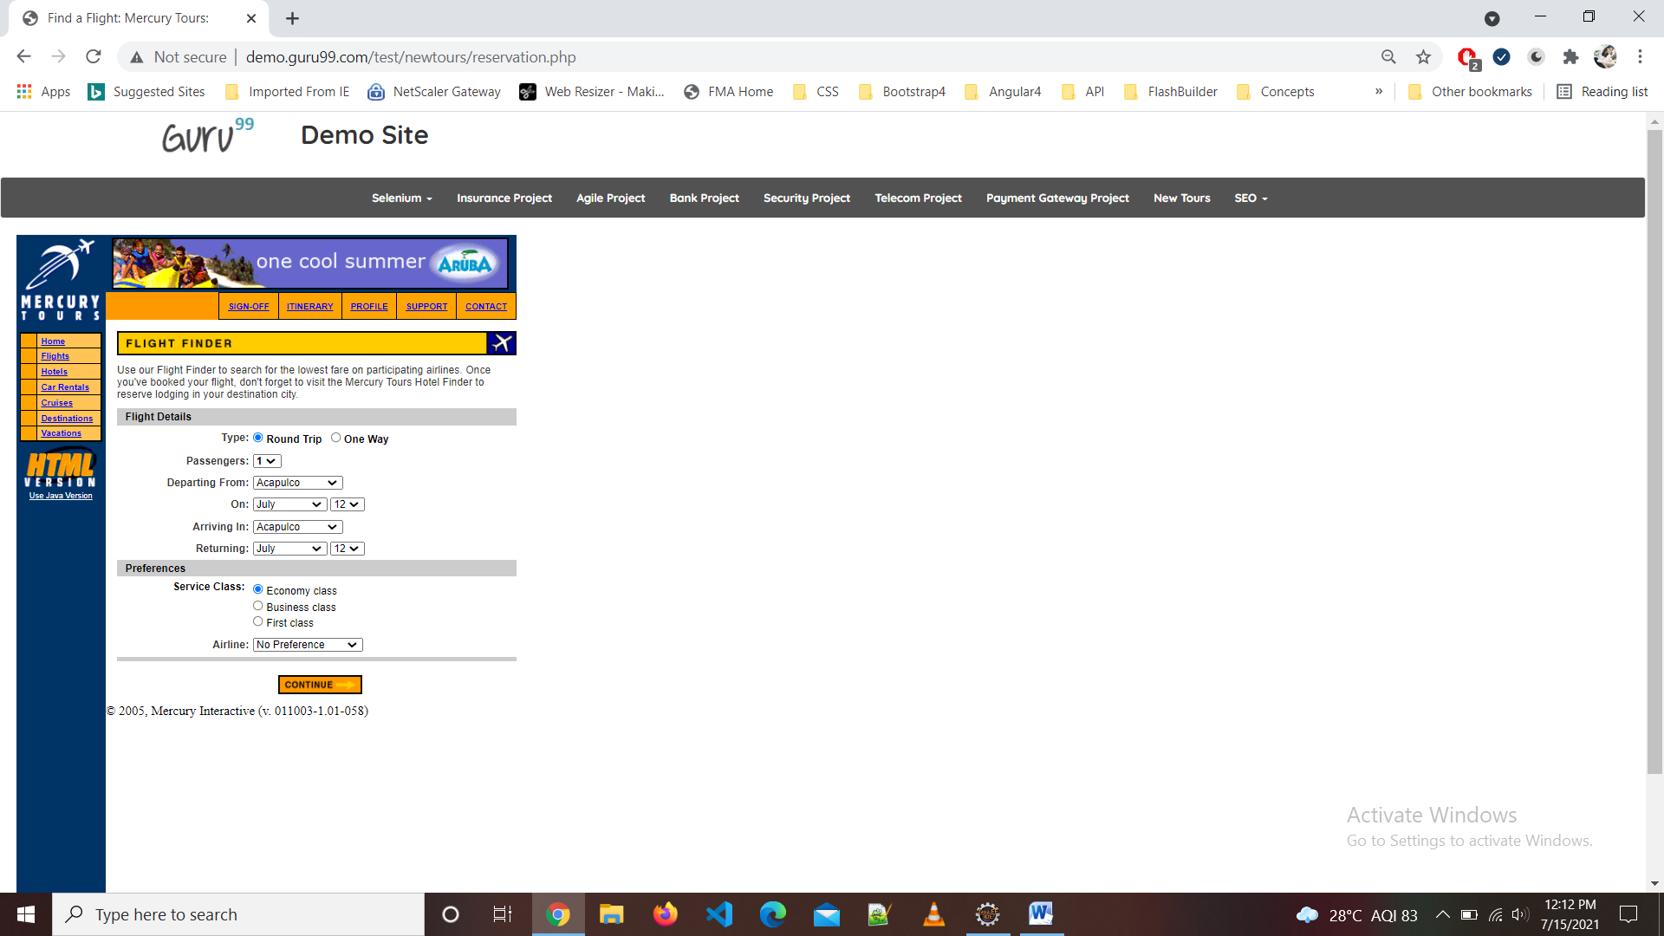

TC08-To check the functionality of HOTELS Button

w1.findElement(By.*linkText*("Hotels")).click();

w1.navigate().back();

Thread.sleep(2000);

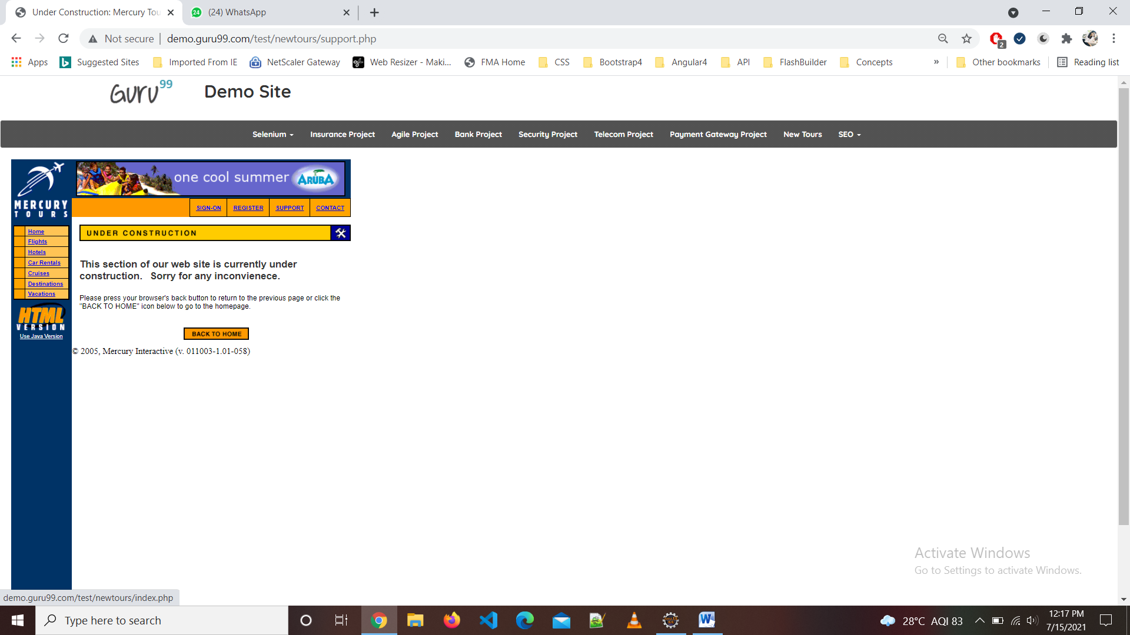

TC09-To check the functionality of Car Rentals Button

w1.findElement(By.*linkText*("Car Rentals")).click();

w1.navigate().back();

Thread.sleep(2000);

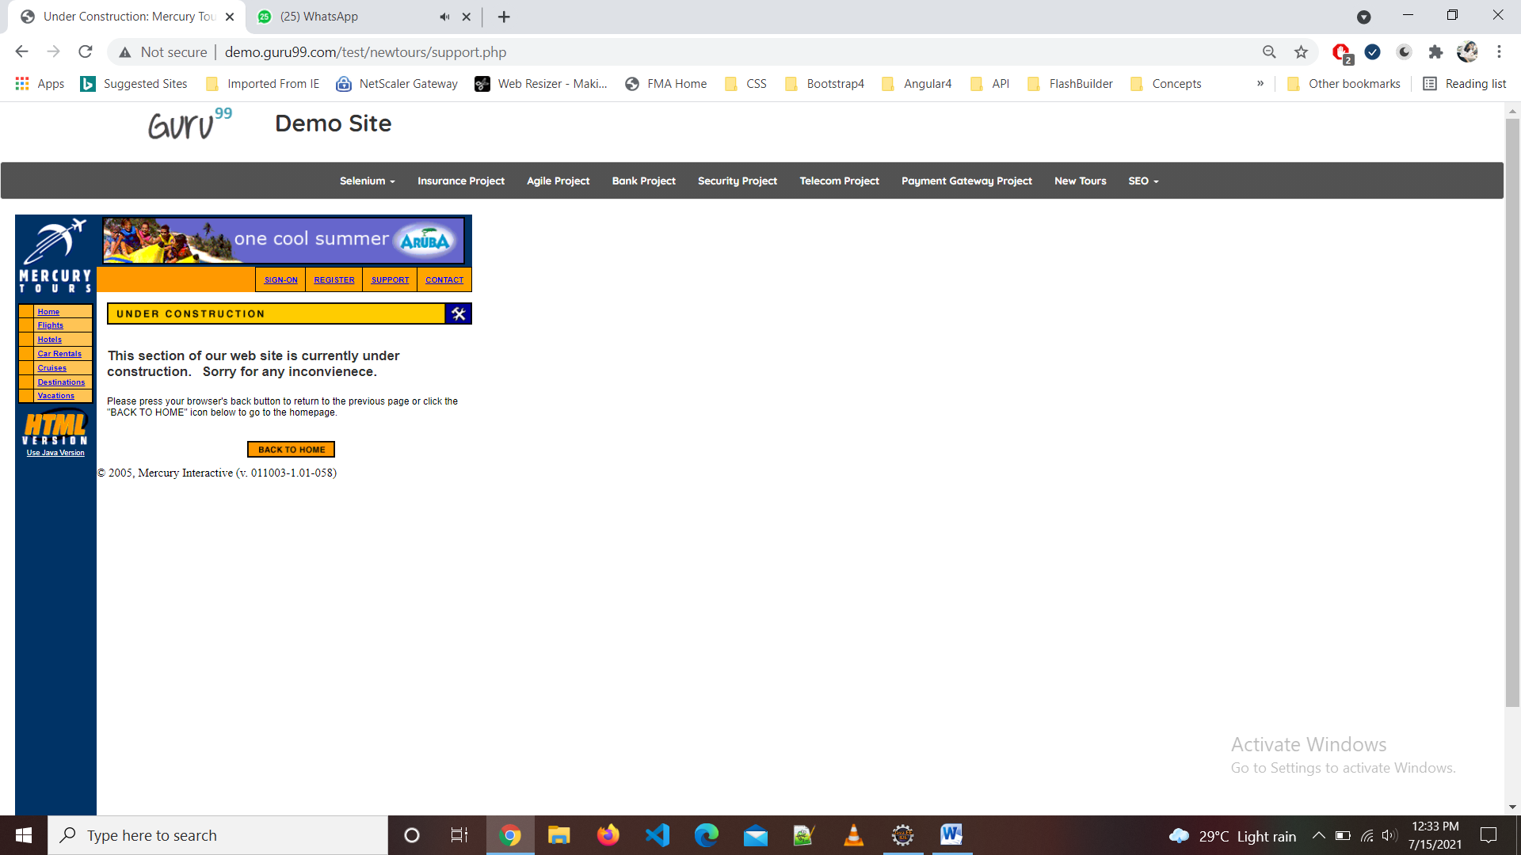

TC10-To check the functionality of Cruises Button

w1.findElement(By.*linkText*("Cruises")).click();

w1.navigate().back();

Thread.sleep(2000);

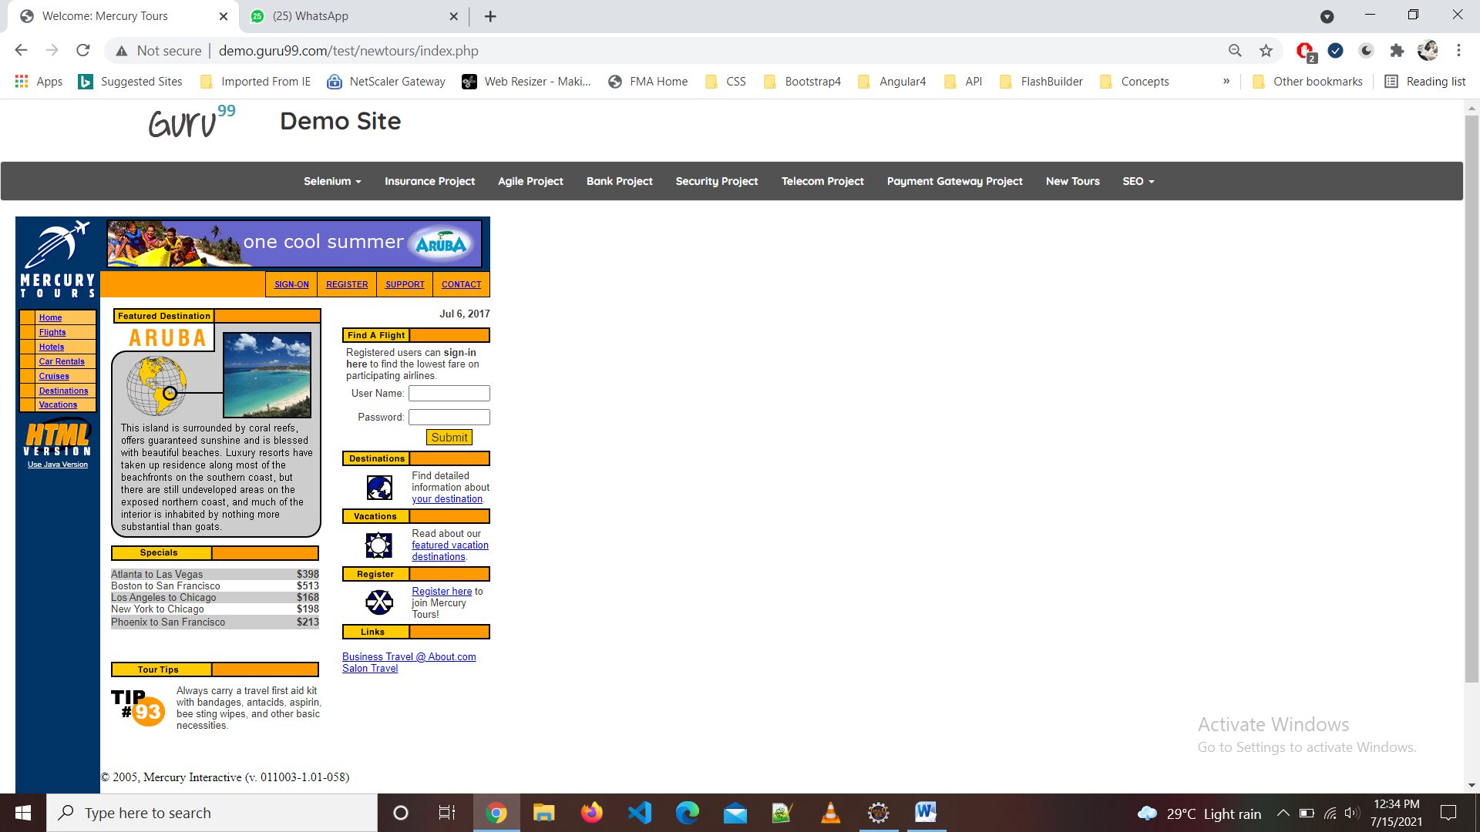

TC11-To check the functionality of Destinations Button

w1.findElement(By.*linkText*("Destinations")).click();

w1.navigate().back();

Thread.sleep(2000);

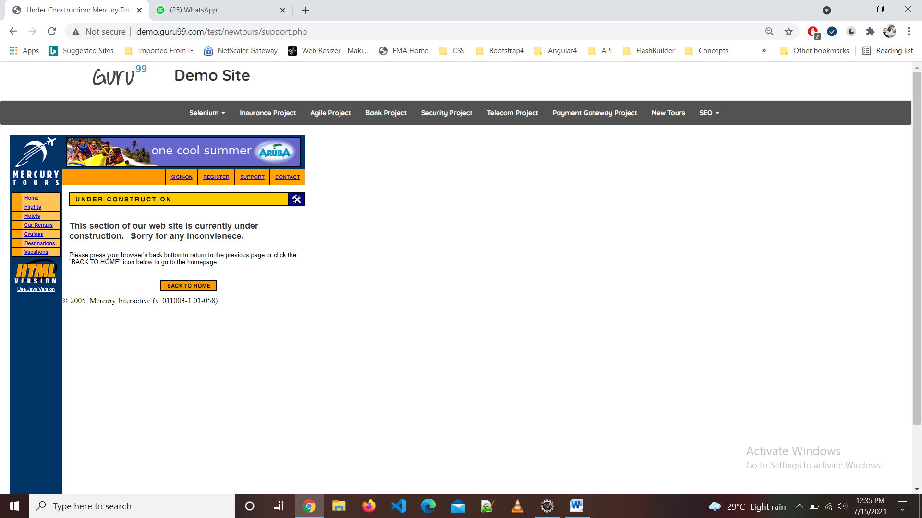

TC12-To check the functionality of Vacations Button

w1.findElement(By.*linkText*("Vacations")).click();

w1.navigate().back();

Thread.sleep(2000);



TC13-To check the functionality of Vacations Button

w1.findElement(By.*linkText*("Vacations")).click();

w1.navigate().back();

Thread.sleep(2000);

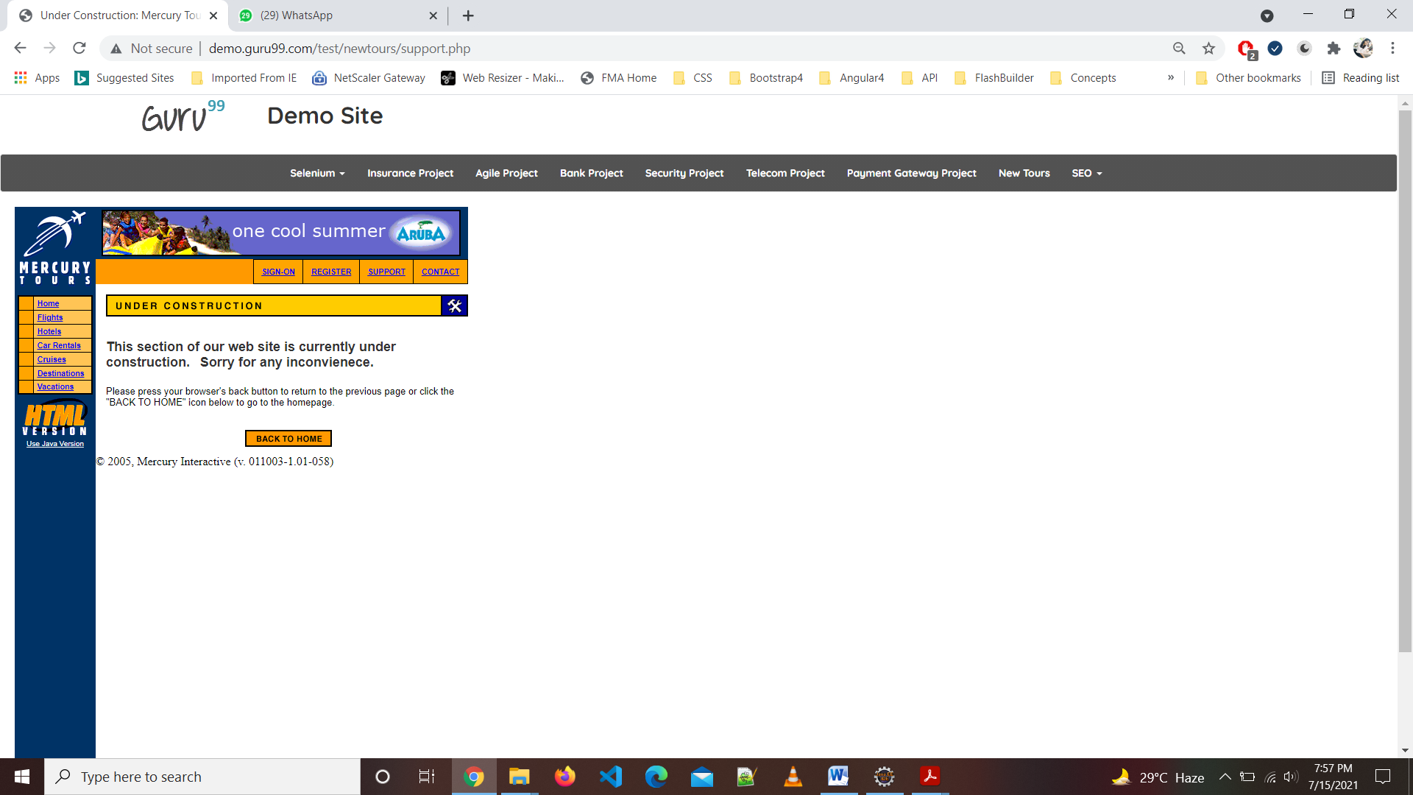

TC14-To check the functionality of Login Page

w1.findElement(By.*name*("userName")).sendKeys("test");

w1.findElement(By.*name*("password")).sendKeys("test");

w1.findElement(By.*name*("submit")).click();

w1.navigate().back();

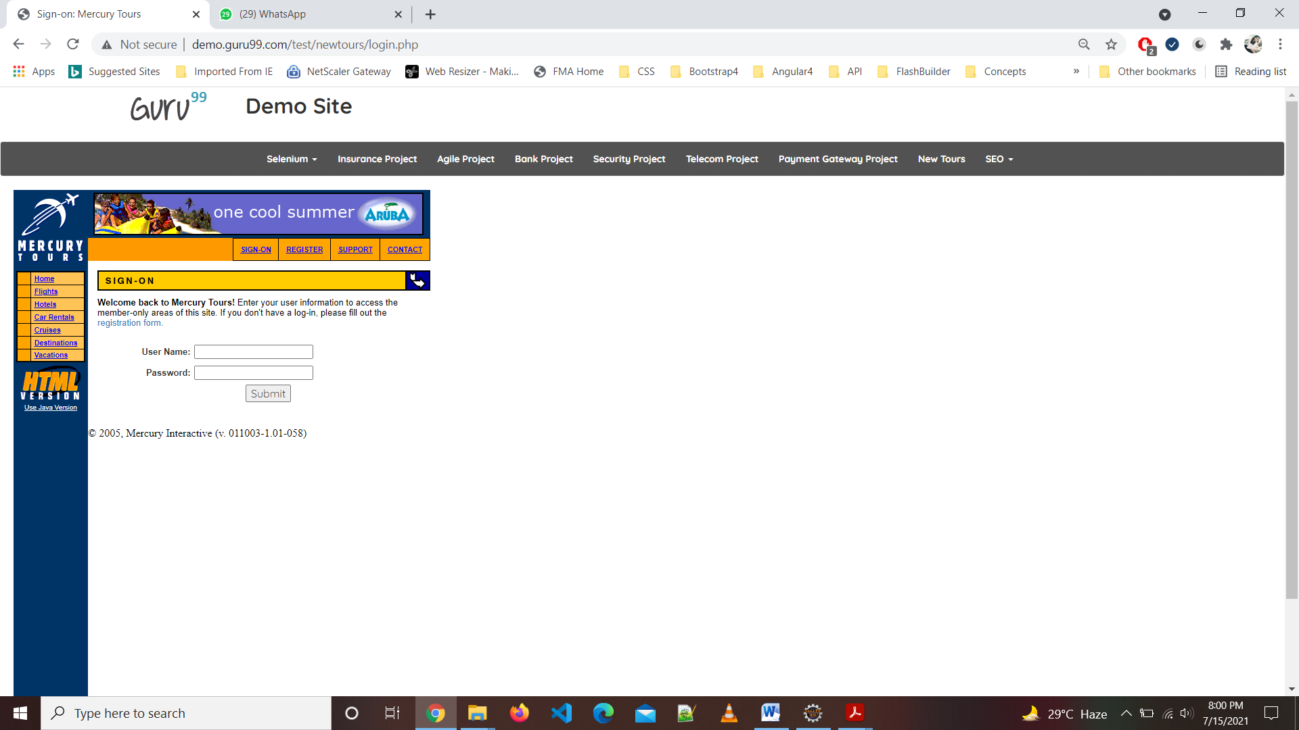

DEFECT: It takes invalid and Blank data

TC15-To check the functionality of Submit button in REGISTER Page

w1.findElement(By.*linkText*("REGISTER")).click();

w1.findElement(By.*name*("firstName")).sendKeys("Rohini");

w1.findElement(By.*name*("lastName")).sendKeys("raut");

w1.findElement(By.*name*("phone")).sendKeys("9172584770");

w1.findElement(By.*name*("userName")).sendKeys("rohiniaraut321.com");

w1.findElement(By.*name*("address1")).sendKeys("akola");

w1.findElement(By.*name*("city")).sendKeys("akola");

w1.findElement(By.*name*("state")).sendKeys("maharastra");

w1.findElement(By.*name*("postalCode")).sendKeys("55302");

Select s=**new** Select(w1.findElement(By.*name*("country")));

s.selectByVisibleText("AUSTRIA");

w1.findElement(By.*name*("email")).sendKeys("rohiniaraut321@gmail.com");

w1.findElement(By.*name*("password")).sendKeys("123456");

w1.findElement(By.*name*("confirmPassword")).sendKeys("123456");

w1.findElement(By.*xpath*("/html/body/div[2]/table/tbody/tr/td[2]/table/tbody/tr[4]/td/table/tbody/tr/td[2]/table/tbody/tr[5]/td/form/table/tbody/tr[17]/td/input")).click();

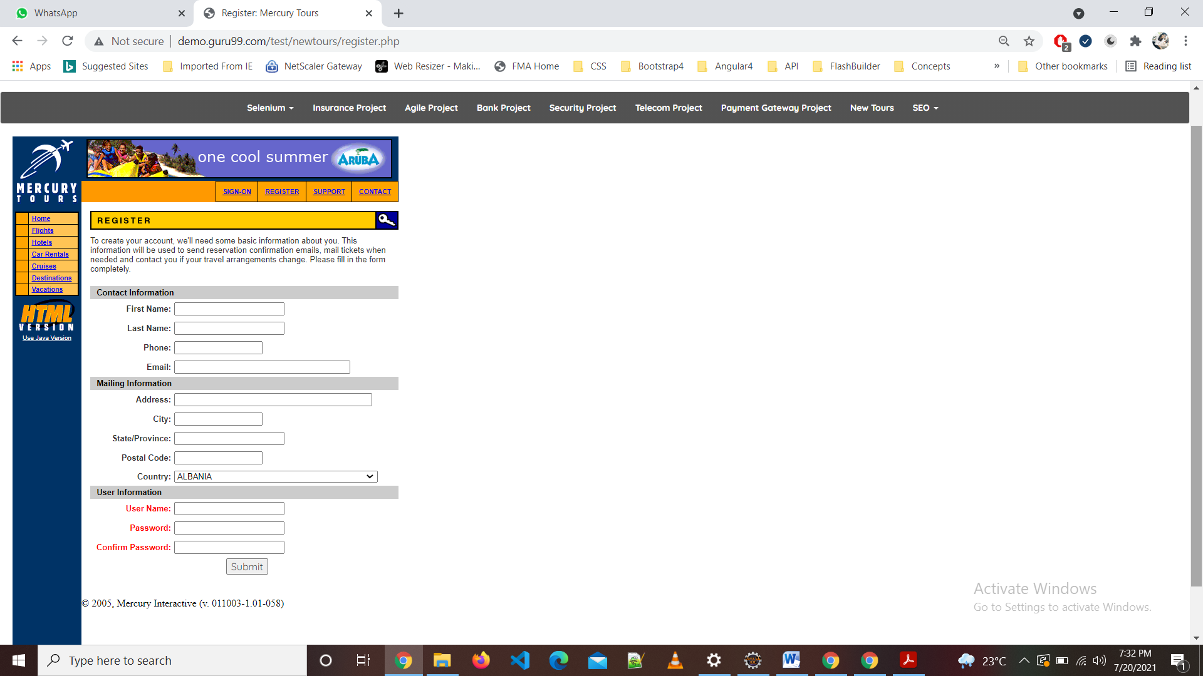

DEFECT: It takes invalid and Blank data

TC16-To check the functionality of Selenium

w1.findElement(By.*xpath*("//*[@id=\"navbar-brand-centered\"]/ul/li[1]/a")).click Thread.*sleep*(1000);

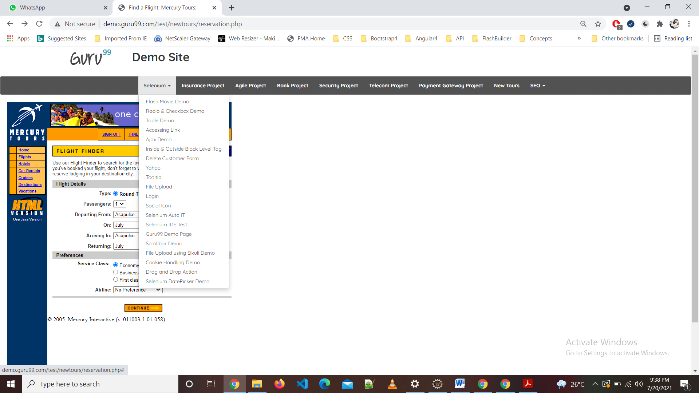

TC17-To check the functionality of Flash Movie Demo in Selenium

w1.findElement(By.*xpath*("//*[@id=\"navbar-brand-centered\"]/ul/li[1]/ul/li[1]/a")).click(); //flash move demo

w1.navigate().back();

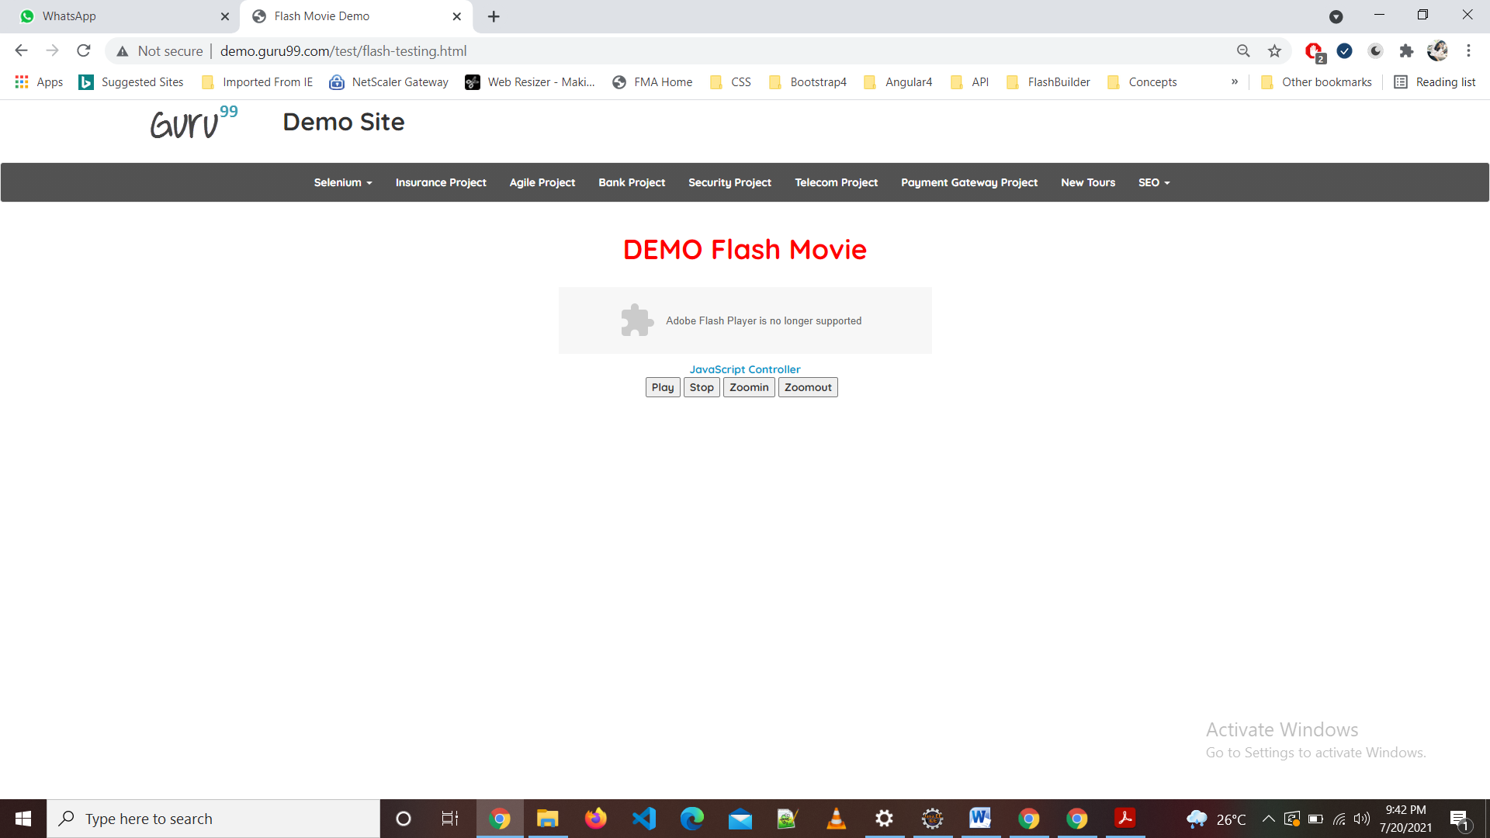

TC18-To check the functionality of Radio and Checkbox Demo in Selenium

w1.findElement(By.*xpath*("//*[@id=\"navbar-brand-centered\"]/ul/li[1]/a")).click(); //radio button

Thread.*sleep*(1000);

w1.findElement(By.*xpath*("//*[@id=\"navbar-brand-centered\"]/ul/li[1]/ul/li[2]/a")).click();

w1.findElement(By.*id*("vfb-7-2")).click();

Thread.*sleep*(1000);

w1.findElement(By.*id*("vfb-6-0")).click(); //checkbox

w1.findElement(By.*id*("vfb-6-2")).click();

w1.navigate().back();

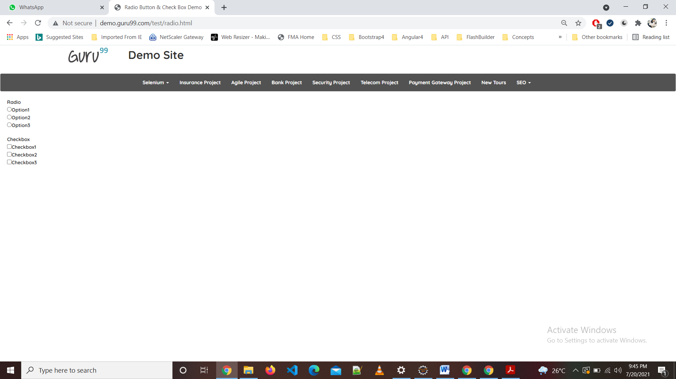

TC19-To check the functionality of Table Demo in Selenium

w1.findElement(By.*xpath*("//*[@id=\"navbar-brand-centered\"]/ul/li[1]/a")).click();

w1.findElement(By.*xpath*("//*[@id=\"navbar-brand-centered\"]/ul/li[1]/ul/li[3]/a")).click(); //tabel

w1.navigate().back();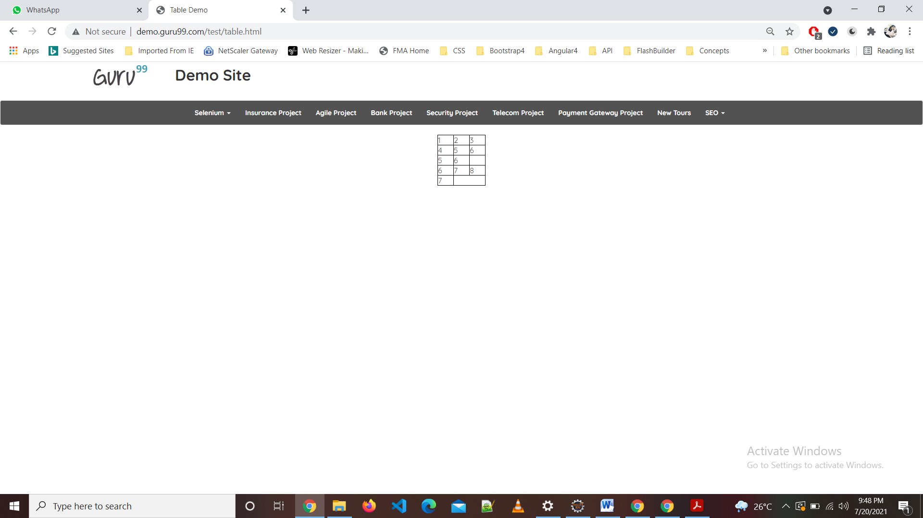

TC20-To check the functionality of Accessing link in Selenium

w1.findElement(By.*xpath*("//*[@id=\"navbar-brand-centered\"]/ul/li[1]/ul/li[4]/a")).click(); //access link

w1.findElement(By.*linkText*("click here")).click();

w1.navigate().back();

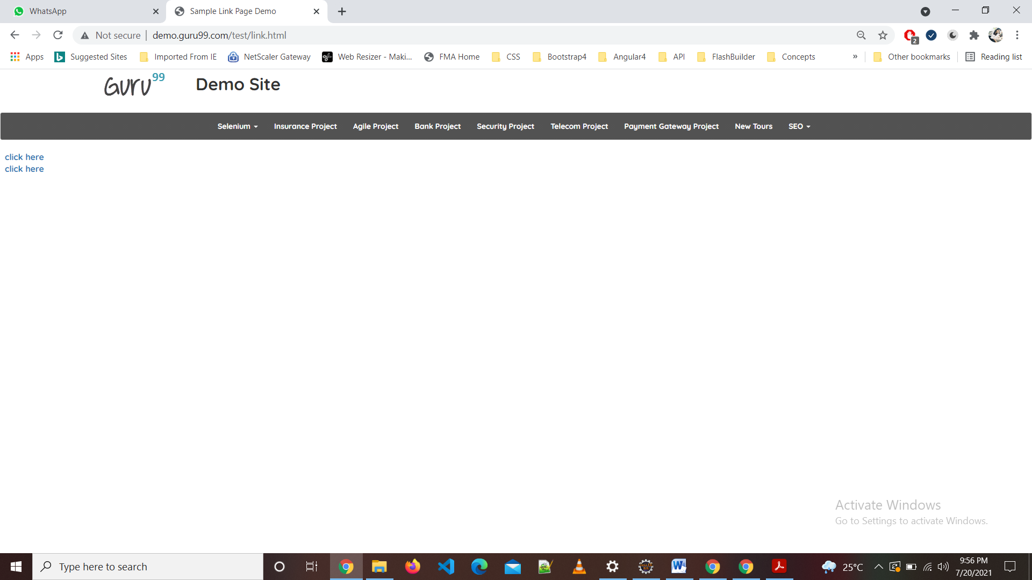

TC21-To check the functionality of Scrollbar Demo in Selenium

w1.findElement(By.*xpath*("//*[@id=\"navbar-brand-centered\"]/ul/li[1]/a")).click();

w1.findElement(By.*xpath*("//*[@id=\"navbar-brand-centered\"]/ul/li[1]/ul/li[16]/a")).click();

w1.manage().window().maximize();

WebElement Element=w1.findElement(By.*xpath*("//*[@id=\"rt-feature\"]/div/div[1]/div/div/div/div/div[6]/div/div/div/div/div[1]/div/div"));

JavascriptExecutor js =(JavascriptExecutor) w1; // JavascriptExecutor is a variable

js.executeScript("arguments[0].scrollIntoView();", Element);

w1.navigate().back();

Thread.*sleep*(2000);

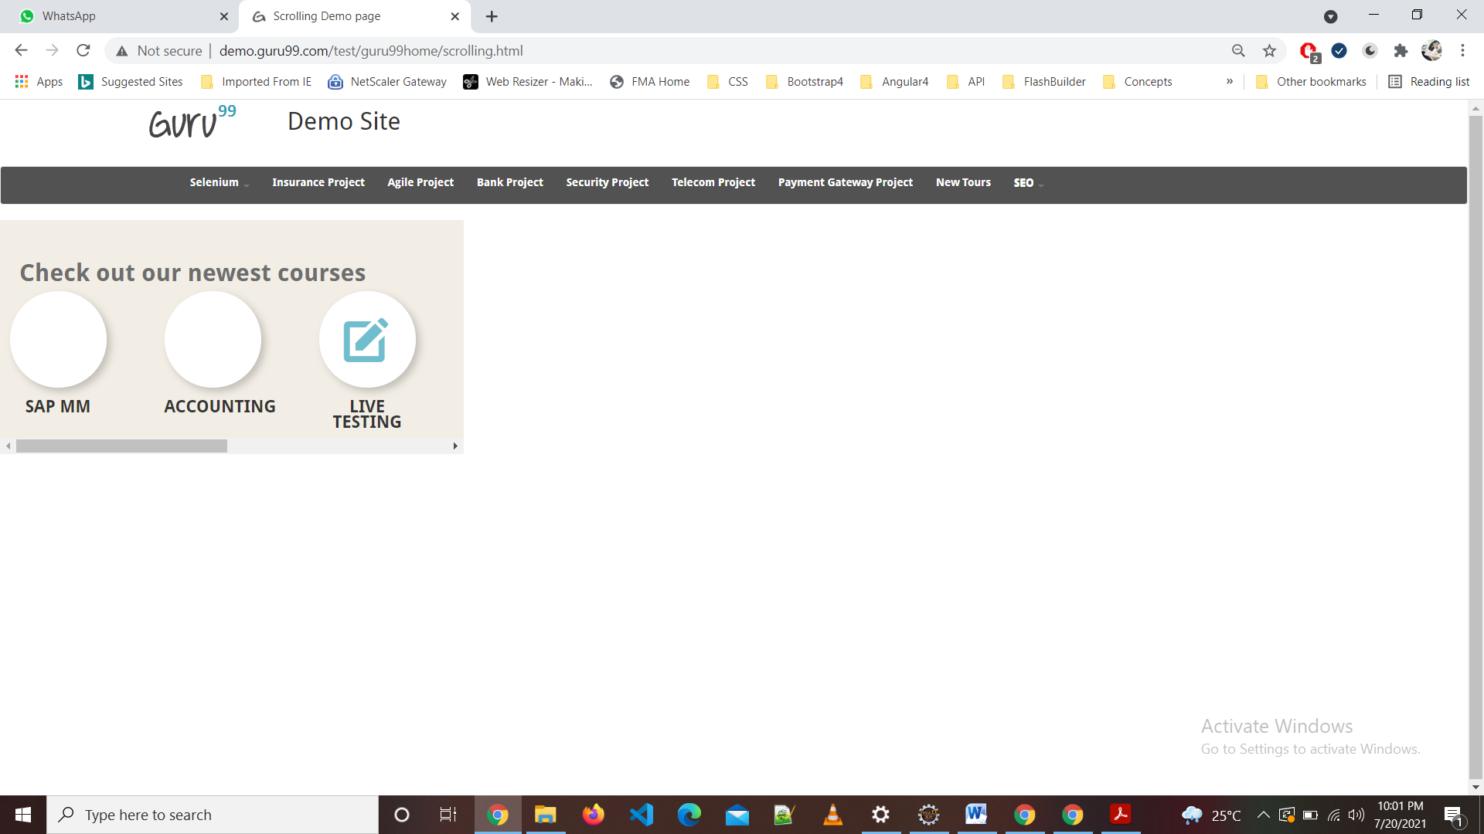

TC22-To check the functionality of Drag and Drop Demo in Selenium

WebElement bank = w1.findElement(By.*partialLinkText*("BANK"));

WebElement drop1 = w1.findElement(By.*xpath*("//body[1]/section[1]/div[1]/div[1]/main[1]/div[1]/div[1]/div[1]/div[1]/div[1]/div[1]/table[1]/tbody[1]/tr[1]/td[1]/table[1]/tbody[1]/tr[1]/td[1]/div[1]/div[1]/ol[1]/li[1]"));

Actions a = **new** Actions(w1);

a.dragAndDrop(bank, drop1).build().perform();

WebElement amt = w1.findElement(By.*xpath*("//body/section[@id='g-container-main']/div[1]/div[1]/main[1]/div[1]/div[1]/div[1]/div[1]/div[1]/div[1]/div[1]/div[1]/ul[1]/li[4]/a[1]"));

WebElement drop2 = w1.findElement(By.*xpath*("//body[1]/section[1]/div[1]/div[1]/main[1]/div[1]/div[1]/div[1]/div[1]/div[1]/div[1]/table[1]/tbody[1]/tr[1]/td[1]/table[1]/tbody[1]/tr[1]/td[2]/div[1]/div[1]/ol[1]/li[1]"));

a.dragAndDrop(amt, drop2).build().perform();

WebElement sales = w1.findElement(By.*partialLinkText*("SALES"));

WebElement drop3 = w1.findElement(By.*xpath*("//body[1]/section[1]/div[1]/div[1]/main[1]/div[1]/div[1]/div[1]/div[1]/div[1]/div[1]/table[1]/tbody[1]/tr[1]/td[2]/table[1]/tbody[1]/tr[1]/td[1]/div[1]/div[1]/ol[1]/li[1]"));

a.dragAndDrop(sales, drop3).build().perform();

WebElement amt2 = w1.findElement(By.*xpath*("//body/section[@id='g-container-main']/div[1]/div[1]/main[1]/div[1]/div[1]/div[1]/div[1]/div[1]/div[1]/div[1]/div[1]/ul[1]/li[2]/a[1]"));

WebElement drop4 = w1.findElement(By.*xpath*("//body[1]/section[1]/div[1]/div[1]/main[1]/div[1]/div[1]/div[1]/div[1]/div[1]/div[1]/table[1]/tbody[1]/tr[1]/td[2]/table[1]/tbody[1]/tr[1]/td[2]/div[1]/div[1]/ol[1]/li[1]"));

a.dragAndDrop(amt2, drop4).build().perform();

w1.navigate().back();

Thread.*sleep*(2000);

System.***out***.println("drag and drop successfuly done");

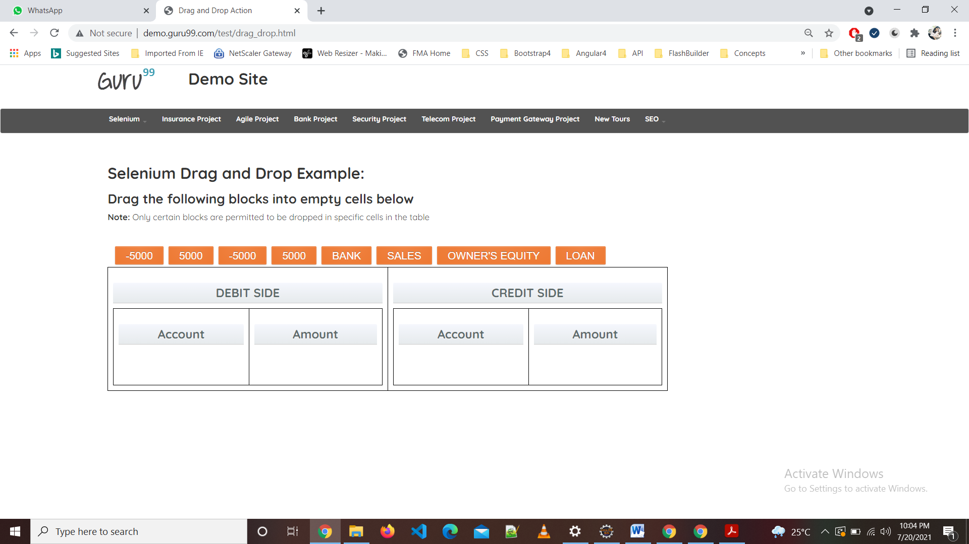

TC23-To check the functionality of insurance project

w1.findElement(By.*xpath*("//*[@id=\"navbar-brand-centered\"]/ul/li[3]/a")).click();

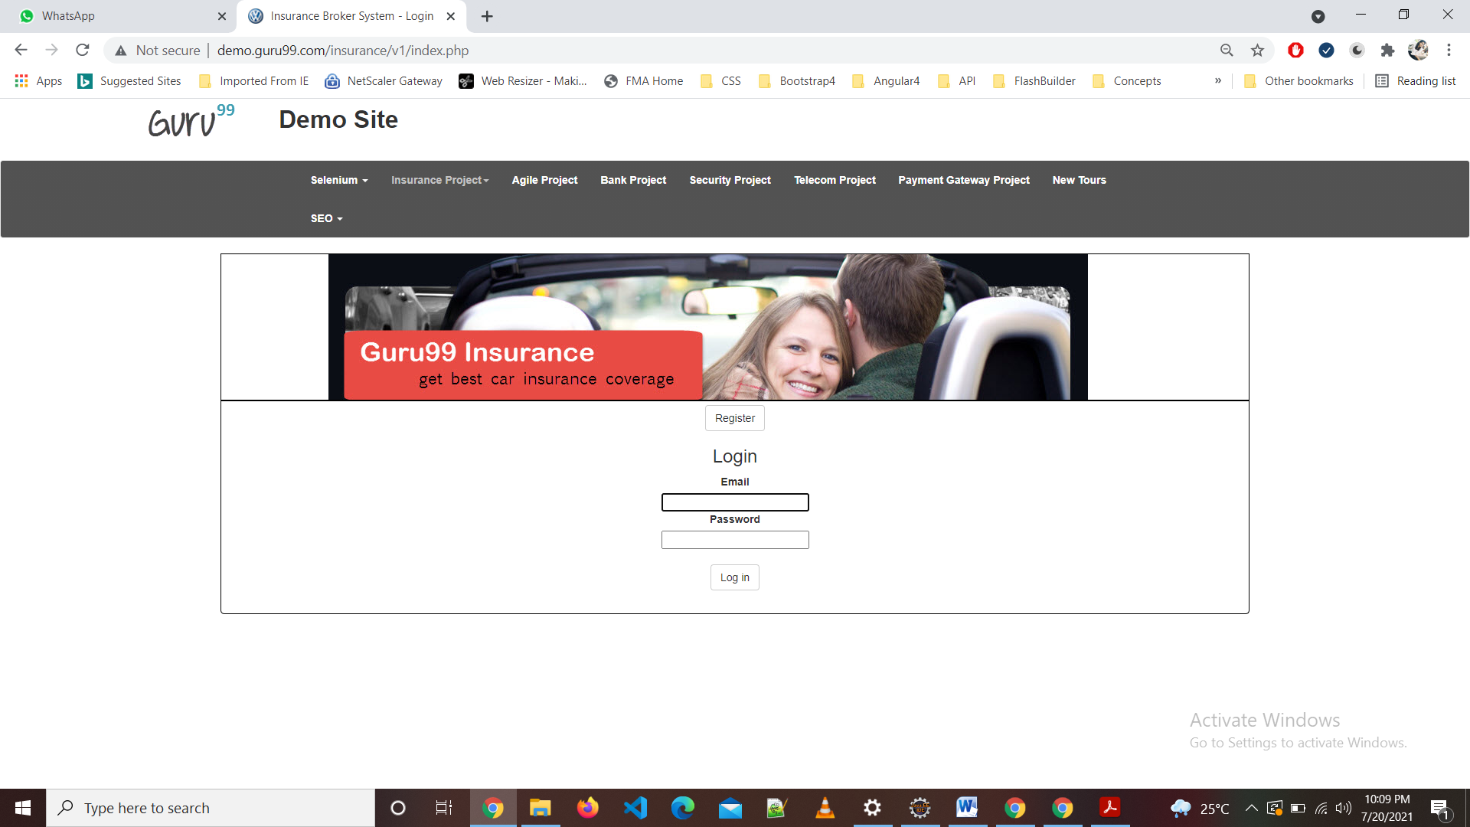

DEFECT: It takes invalid and Blank data

TC24-To check the functionality of Register insurance project

w1.findElement(By.*xpath*("/html/body/div[3]/a")).click();

TC25-To check the functionality of Create Button

Select s1=**new** Select(w1.findElement(By.*name*("title")));

s1.selectByVisibleText("Miss");

w1.findElement(By.*name*("firstname")).sendKeys("Rohini");

w1.findElement(By.*name*("lastname")).sendKeys("Raut");

w1.findElement(By.*name*("phone")).sendKeys("7774028281");

Select s2=**new** Select(w1.findElement(By.*name*("year")));

s2.selectByVisibleText("1995");

Select s3=**new** Select(w1.findElement(By.*name*("date")));

s3.selectByVisibleText("4");

w1.findElement(By.*xpath*("//*[@id=\"new_user\"]/div[2]/div[4]/label[2]")).click();

Select s4=**new** Select(w1.findElement(By.*name*("licenceperiod")));

s4.selectByVisibleText("4");

w1.findElement(By.*name*("street")).sendKeys("Akola");

w1.findElement(By.*name*("city")).sendKeys("Akola");

w1.findElement(By.*name*("county")).sendKeys("India");

w1.findElement(By.*name*("post_code")).sendKeys("444501");

w1.findElement(By.*name*("email")).sendKeys("rautrohini07@gmail.com");

w1.findElement(By.*name*("password")).sendKeys("123456");

w1.findElement(By.*name*("c_password")).sendKeys("123456");

w1.findElement(By.*name*("submit")).click();

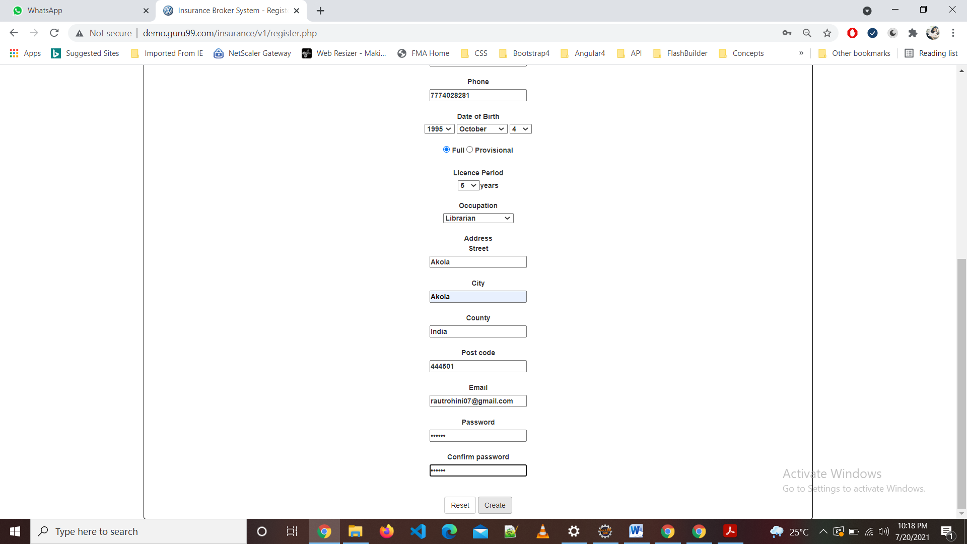

DEFECT: It takes invalid and Blank data

TC26-To check the functionality of Login Button

w1.findElement(By.*name*("email")).sendKeys("rautrohini07@gmail.com");

w1.findElement(By.*name*("password")).sendKeys("123456");

w1.findElement(By.*name*("submit")).click();

w1.findElement(By.*xpath*("/html/body/div[3]/form/input")).click();

w1.navigate().back();

DEFECT: It takes invalid and Blank data

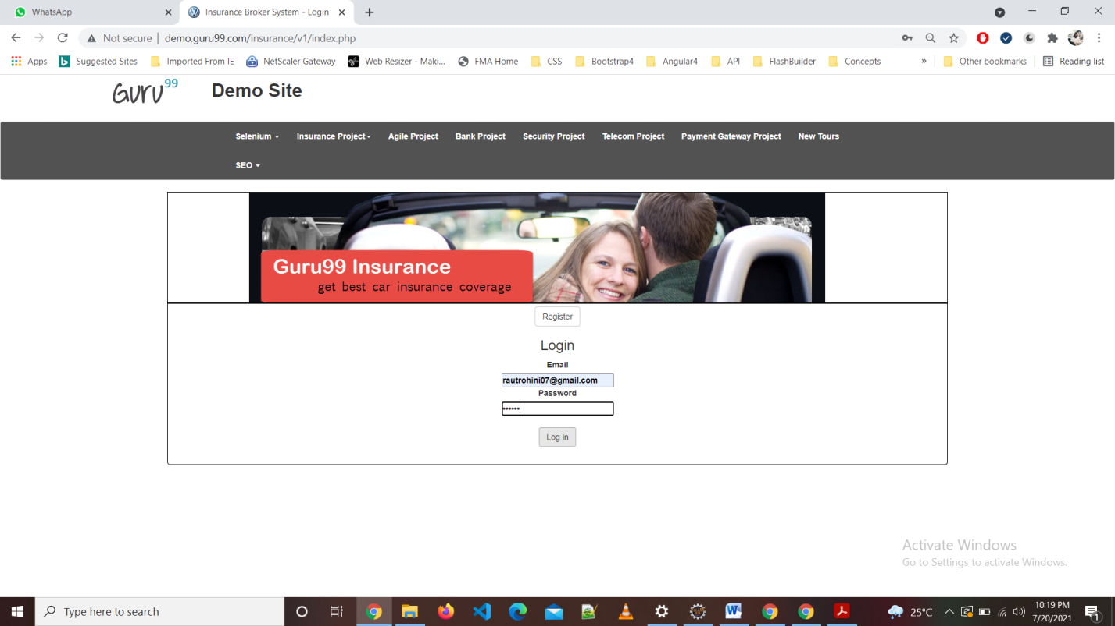

DEFECT: It takes invalid and Blank data

TC27-To check the functionality of New Tour

w1.findElement(By.*xpath*("//*[@id=\"navbar-brand-centered\"]/ul/li[10]/a")).click();

TC28-To check the functionality of Agile Project

w1.findElement(By.*linkText*("Agile Project")).click();//agile project

w1.navigate().back();

TC29-To check the functionality of Bank Project

w1.findElement(By.*linkText*("Bank Project")).click();//bank project

w1.navigate().back();

TC30-To check the functionality of Security Project

w1.findElement(By.*linkText*("Security Project")).click();//security project

w1.navigate().back();

TC31-To check the functionality of Telecom Project

w1.findElement(By.*linkText*("Telecom Project")).click();

TC33-To check the functionality of Add Customer

w1.findElement(By.*linkText*("Add Customer")).click();//add cutomer

TC34-To check the functionality of Submit Button

w1.findElement(By.*xpath*("//*[@id=\"main\"]/div/form/div/div[1]/label")).click();

w1.findElement(By.*xpath*("//*[@id=\"fname\"]")).sendKeys("Mohini");

w1.findElement(By.*id*("lname")).sendKeys("raut");

w1.findElement(By.*id*("email")).sendKeys("rautrohini07@gmail.com");

w1.findElement(By.*tagName*("textarea")).sendKeys("Akola");

w1.findElement(By.*xpath*("//*[@id=\"telephoneno\"]")).sendKeys("9172584770");

w1.findElement(By.*xpath*("//*[@id=\"main\"]/div/form/div/div[9]/ul/li[1]/input")).click();//submit

Thread.*sleep*(3000);

w1.findElement(By.*xpath*("//*[@id=\"main\"]/div/div/ul/li/a")).click();//homepage

TC35-To check the functionality of Pay Button in Payment GateWay

w1.findElement(By.*linkText*("Payment Gateway Project")).click();

w1.findElement(By.*xpath*("//*[@id=\"three\"]/div/form/div/div[4]/select")).click();

w1.findElement(By.*xpath*("//*[@id=\"three\"]/div/form/div/div[8]/ul/li/input")).click();

w1.findElement(By.*tagName*( "img")).click();

w1.findElement(By.*xpath*("//*[@id=\"card_nmuber\"] ")).sendKeys("1010203569874231");

Select p=**new** Select(w1.findElement(By.*name*("month")));

p.selectByVisibleText("05");

Select x=**new** Select(w1.findElement(By.*name*("year")));

x.selectByVisibleText("2025");

w1.findElement(By.*xpath*("//*[@id=\"cvv_code\"]")).sendKeys("699");

w1.findElement(By.*xpath*("//*[@id=\"three\"]/div/form/div[2]/div/ul/li/input")).click();

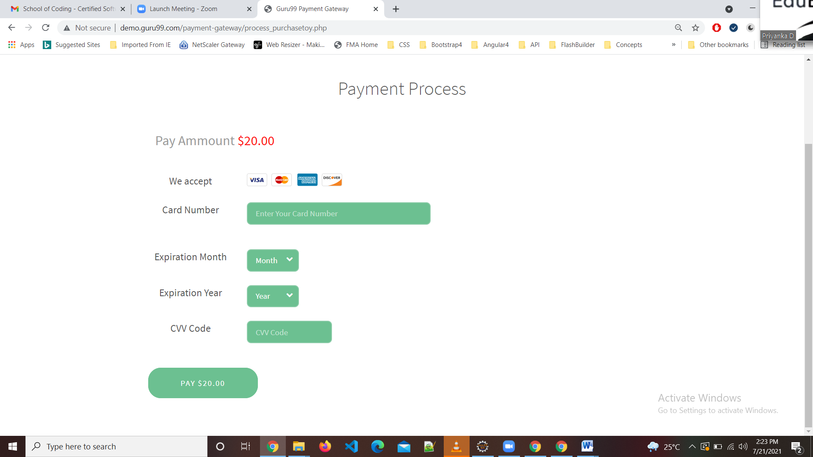

DEFECT: It takes only visa card number

**Console Window:**

